# NATIONAL ASSOCIATION OF UNIVERSITY WOMEN

Volume 4, Issue 5

February 2014



**My NAUW Culver City Sisters,**

**CONGRATULATIONS TO OUR SOUTHWEST SECTIONAL WOMAN OF THE YEAR KENYA DENNIS!!!** This is a well-deserved honor. Kenya faced stiff competition; but in the end, she emerged the victor. This is Kenya’s second time as our Southwest Sectional Woman of the Year. The **Culver City Branch** is very fortunate to have her as a member.

The **Culver City Branch Stars** were on full display Friday night at the Doubletree Hotel by Hilton Penthouse. We showed up and showed out. Our skit for the **Harlem Renaissance Experience** was a lot of fun. I think we all had a good time. Our performance was good enough to earn second place in the competition. We moved up one place since last. Year.

The **Culver City Branch** is to be applauded for hosting this year’s **Southwest Sectional Conference. Our Conference Co-Chairs, Hester Watkins and Herracia Brewer** did a fantastic job. Everyone pitched in and helped out when called upon. You ladies really are **“STARS.”** Our own **Southwest Sectional Director Evelyn Wright** deserves kudos for a job well done. She kept us on time and the agenda moving. She even found time to offer a few surprises for us along the way.

A **special thanks goes to Kendall Dennis and her mother, Kenya Dennis. Kendall** performed an amazing tap dance at our **Harlem Experience** on Fridaynight; She synchronized her steps to those of the Nicholas Brothers on film. Thanks for a wonderful routine and great performance.

**February is** **Black History Month.** We will have a special presentation at our meeting on Sunday. Don’t forget that we will be having a **Soul Food Potluck** on Sunday. **PLEASE WEAR AFRICAN ATTIRE** as we honor our Black ancestors and celebrate our culture. The list of those who signed up to bring food will be found on the following page.

Now that the **SOUTHWEST SECTIONAL CONFERENCE** is over, we can begin to really focus on our **Community Fair Event** scheduled for **Saturday, April 26, 2014, at St. John’s United Methodist Church located at 1715 Santa Ana Boulevard.**

**SAVE THE DATE OF April 26, 2014, for the** **COMMUNITY FAIR.**

**God bless you!**

**Helen Ricks, President**

.

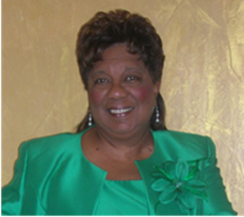

CULVER CITY STAR

## **PRESIDENT’S CORNER**

culver city nauw:

**Executive Board 2012-2014**

**President**

**Helen Ricks**

**1st Vice President**

**Mildred Slaughter**

**2nd Vice President**

**Carolyn Williams**

**Recording Secretary**

**Clarissa Andrews**

**Corresponding Secretary**

**Herracia Brewer**

**Financial Secretary**

**Hester Watkins**

**Treasurer**

**Kenya Dennis**

**Historian**

**Dr. Virginia Hathaway**

**Parliamentarian**

**Dr. Claretha Graham**

**Immediate Past President**

**Mildred Slaughter**

**SECTIONAL DIRECTOR**

**EVELYN L. WRIGHT**

**NATIONAL PRESIDENT**

**DOLORES Y. OWENS**

**NATIONAL THEME:**

**“Women Moving Forward with Purpose and Pride”**

**CULVER CITY STAR**

Page 2

## **SICK AND SHUT-IN**

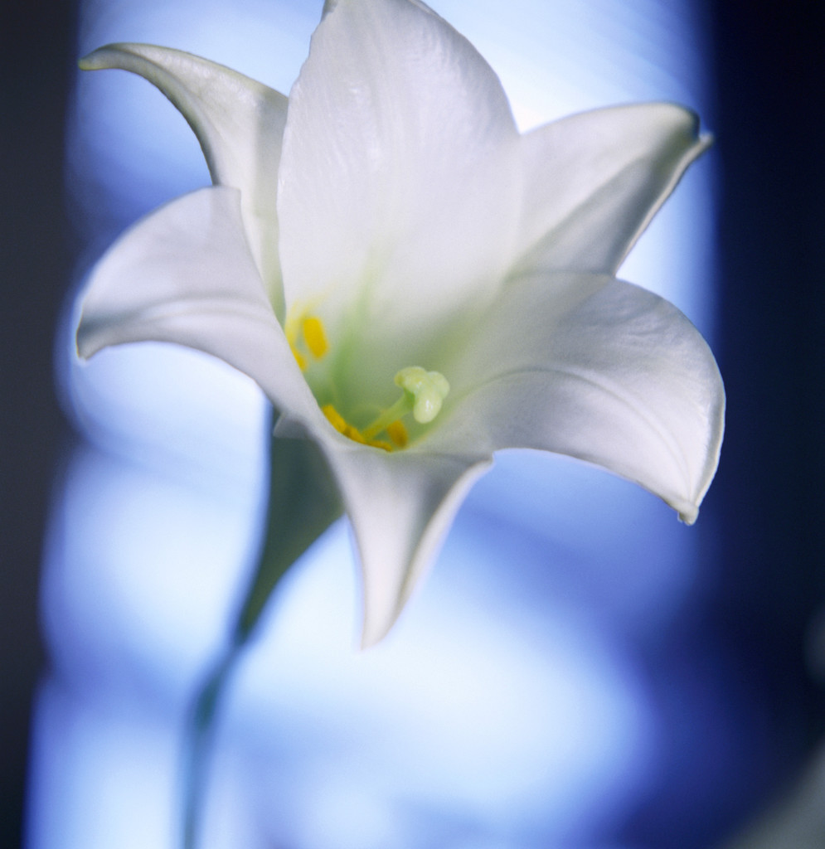

“For God has not given us the spirit of fear, but of power, and of love and of sound mind.”

2nd Timothy 1:7

BIRTHDAYS AND ANNIVERSARIES

**February**

**Evelyn Wright 2/04**



**Red Dress Day Saturday, February 22, 2014 Inglewood High School Inglewood Branch**

**Community Fair Saturday, April 26, 2014 St. John’s UM Church 1715 Santa Ana Blvd.**

**Spotlight on Youth Luncheon, Sunday, April 27, 2014, 1:00 p. m. Doubletree by Hilton Torrance $65**

**Mailing Address**: NAUW Culver City Branch P.O. Box 2524 Culver City CA 90231-2524

**SOUL FOOD SIGN-UP** Mildred Slaughter Cornbread Kenya Dennis –Green Bean with potatoes Herracia Brewer-Black-eyed peas Evelyn Wright- Jambalaya Mattleal Kirby- Salad Ruthie Williams – Drinks Claretha L. Graham- Mixed nuts Roberta A. Jones – Dessert Virginia Hathaway – Chips Elnora Rodgers – Turkey Loaf Helen Ricks – Baked Chicken Hester Watkins - Greens Clarissa Andrews – Mac & Cheese Carolyn Williams - Dessert



### **Dates to Remember**

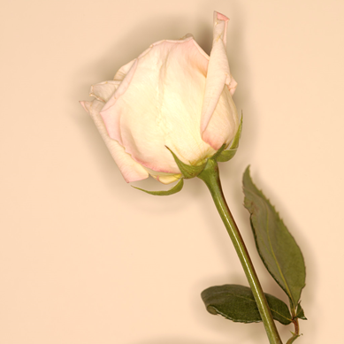

Continue to pray for the following members: Evelyn Wright and family; Odessia Love, who is recuperating; and Carolyn Williams, who is mending from a broken foot.

